TABLE OF CONTENTS

S.No | Objectives | Page No
1 | Introduction of the Project | 1 of 7
2 | Project Objective | 1 of 7
3 | Background Problem | 1 of 7
4 | Project Purpose | 1 of 7
5 | Development Effort Triggered Requirement | 1 of 7
6 | Languages & Technologies Used | 1 of 7
7 | Project Features | 1 of 7
8 | Plan Of Work | 1 of 7
9 | Contribution of each person | 1 of 7
10 | Project GitHub Repository Link | 1 of 7
11 | User Guide With Snapshots | 1 of 7
12 | Flowchart/System flow diagram | 1 of 7
13 | Conclusion | 1 of 7
14 | Future Expansion | 1 of 7

Introduction of the Project
Construction Management System (CMS) is a modern frontend web application designed to help construction companies manage projects, workers, resources, schedules, and project progress efficiently. The system provides a user-friendly interface that allows project managers and team members to monitor construction activities and access project information from a centralized platform.

Project Objective
The main objective of this project is to design and develop a responsive frontend website using HTML, CSS, and Bootstrap that demonstrates how construction projects can be managed digitally. The website aims to provide an organized and professional platform for monitoring construction operations.

Background Problem
Traditional construction project management often relies on paperwork, spreadsheets, and manual communication methods. These approaches can lead to delays, data inconsistency, poor coordination, and difficulty in tracking project progress. Construction companies need a centralized system that provides easy access to project information and improves communication among stakeholders.

Project Purpose
The purpose of this project is to create a professional Construction Management System interface that helps users visualize and manage construction-related activities. The website will provide information about projects, services, project progress, workforce management, and construction resources in a modern and accessible way.

Development Effort Triggered Requirement
(Perform after Mid-Term as mentioned in the template.)

Languages & Technologies Used

Frontend Technologies
- HTML5
- CSS3
- Bootstrap 5
- Bootstrap Icons

Development Tools
- Visual Studio Code
- GitHub
- GitHub Pages

Purpose of Technologies
HTML5
- Used to create the structure of the website.
- Defines sections such as Home, About, Services, Projects, Team, and Contact.
CSS3
- Used for styling and layout design.
- Provides colors, spacing, animations, and responsive appearance.
Bootstrap 5
- Used to create a responsive and mobile-friendly website.
- Provides ready-made components such as Navbar, Cards, Buttons, Forms, and Grid System.
Bootstrap Icons
- Used to add professional icons for services, navigation, and social media.
Visual Studio Code
- Used as the development environment for writing and editing code.
GitHub & GitHub Pages
- Will be used after Mid-Term for project hosting and deployment.
GitHub Uploaded Status: NO (Mid-Term Phase)
GitHub Website Live Status: NO (Mid-Term Phase)

Project Features
- Responsive Navigation Bar
- Professional Hero Section
- Construction Company Introduction
- Project Statistics Dashboard
- Services Management Section
- Featured Construction Projects Gallery
- Team Members Section
- Contact Form
- Mobile-Friendly Responsive Design
- Bootstrap-Based Modern User Interface
- Project Information Cards
- Professional Footer Section
- Login Page Design
- Dashboard Interface Design
- Construction-Themed Color Scheme

Plan Of Work
Phase 1:
• Topic Selection
• Requirement Gathering
• Project Research
Phase 2:
• UI/UX Design Planning
• Wireframe Creation
• Website Layout Design
Phase 3:
• Frontend Development using HTML, CSS, and Bootstrap
Phase 4:
• Testing and Responsiveness Check
Phase 5:
• GitHub Repository Upload
• GitHub Pages Deployment
Phase 6:
• Final Documentation and Presentation

Contribution of Each Person
Member 1:
• Project Idea Selection
• Homepage Design
• Documentation Writing
Member 2:
• Services and Projects Page Design
• Bootstrap Components Integration
• Presentation Preparation
Member 3:
• Contact Page Design
• Testing and Quality Assurance
• Documentation Support
Member 4:
• Dashboard and Login Interface Design
• GitHub Upload and Deployment
• Final Project Review

Description or Idea of Project Activities
The idea of creating a Construction Management System was inspired by the growing need for digital transformation in the construction industry. Many construction companies face challenges in managing multiple projects, tracking workforce activities, monitoring resources, and maintaining project schedules. Therefore, a modern web-based Construction Management System was selected as the project topic.
Information Gathering:
Several construction company websites, project management platforms, UI design references, and Bootstrap-based dashboards were studied to understand modern construction management practices and user interface design principles.
References:
- https://getbootstrap.com
- https://www.w3schools.com
- https://developer.mozilla.org
- https://github.com
- https://themeforest.net
- https://dribbble.com

Project GitHub Repository Link
(To be added after Mid-Term)

User Guide With Snapshots
(To be added after Mid-Term)

Flowchart / System Flow Diagram
User Visits Website
↓
Home Page
↓
View Services
↓
Explore Projects
↓
View Team Members
↓
Contact Company
↓
Submit Inquiry

Conclusion
The Construction Management System project provides a professional and modern frontend solution for managing construction-related information. The project demonstrates practical implementation of HTML, CSS, and Bootstrap while creating a responsive and visually appealing website interface.

Future Expansion
- User Authentication System
- Project Tracking Dashboard
- Employee Management Module
- Resource Management System
- Budget Tracking Module
- Real-Time Project Progress Monitoring
- Client Portal
- Report Generation System
- Database Integration
- Mobile Application Development

Background Problem
Traditional construction project management often relies on paperwork, spreadsheets, and manual communication methods. These approaches can lead to delays, data inconsistency, poor coordination, and difficulty in tracking project progress. Construction companies need a centralized system that provides easy access to project information and improves communication among stakeholders.

Project Purpose
The purpose of this project is to create a professional Construction Management System interface that helps users visualize and manage construction-related activities. The website will provide information about projects, services, project progress, workforce management, and construction resources in a modern and accessible way.

Project Objective

Cc
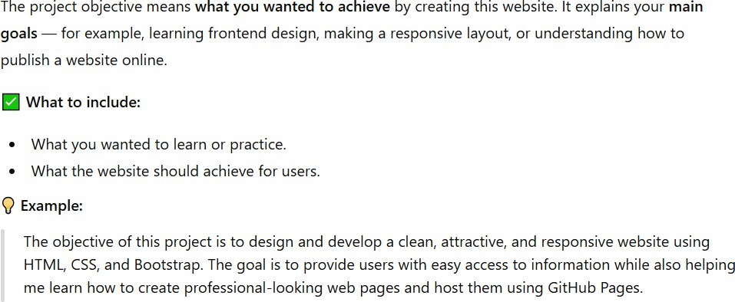

Background Problem

S
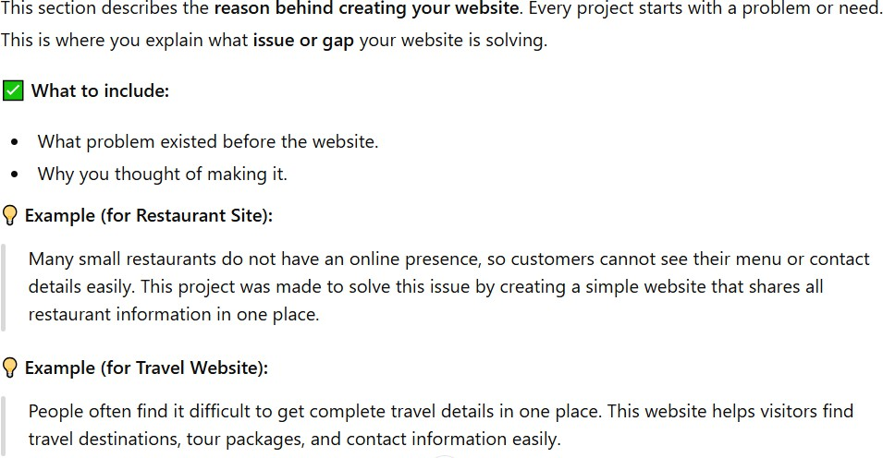

Project Purpose

C
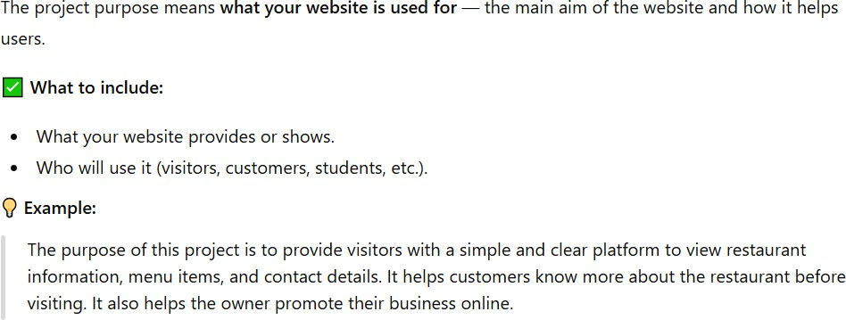

Department of Computer Science

Development Effort Triggered Requirement

Perform after mid so don’t do it in mid term
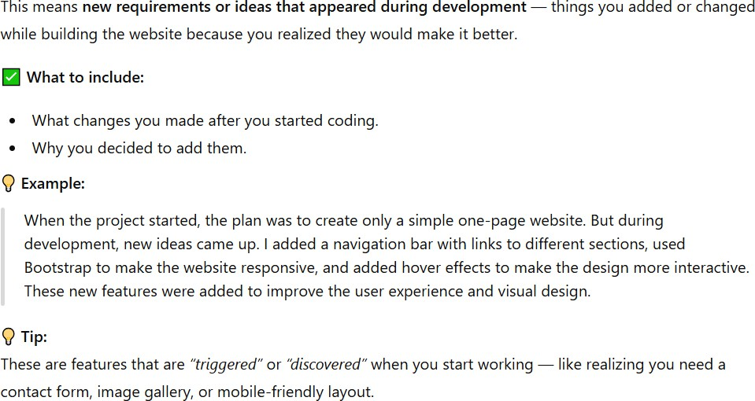

Languages & Technologies Used

C
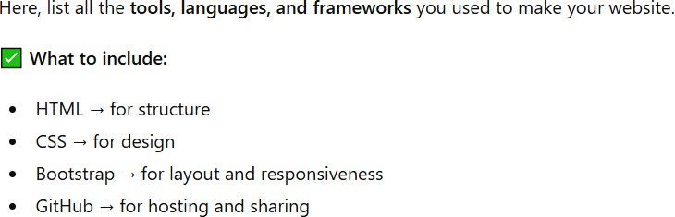

Frontend | HTML CSS Bootstrap 5
Github Uploaded Status | YES/NO
Github Website Live Status | YES/NO
Other things

Department of Computer Science

Project Features

Z
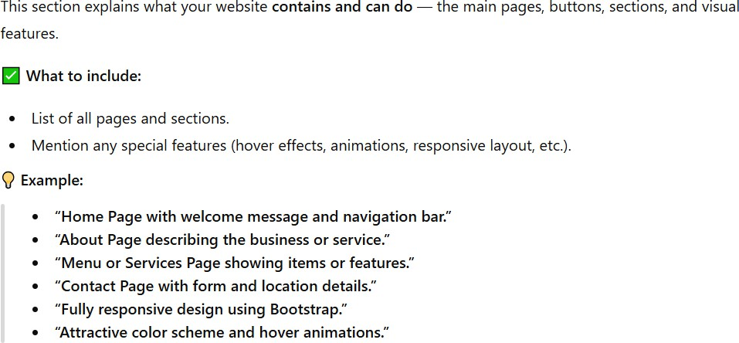

Plan Of Work

B
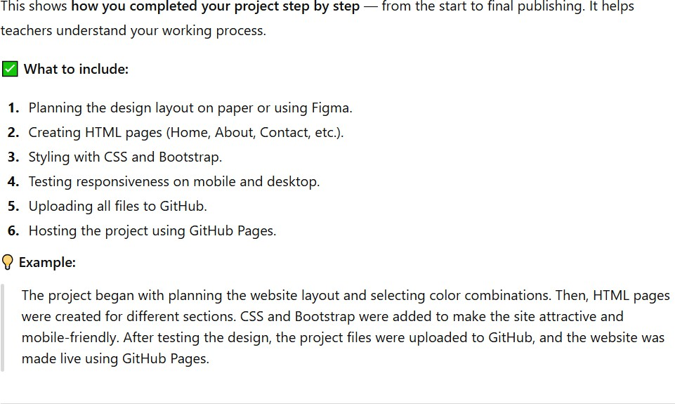

Contribution of Each Person

B
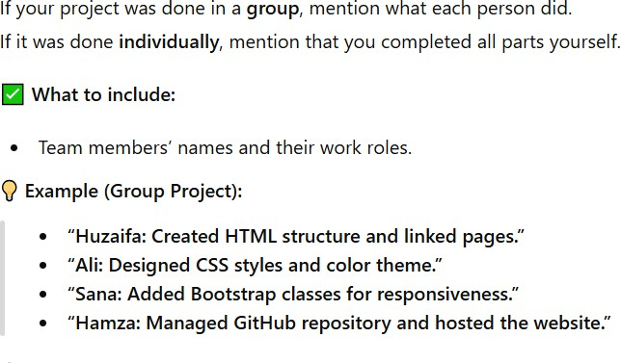

Description or Idea of Project Activities:
Idea of creating Electoral E_Voting System is gathered with the help of real life examples which isobserved during the election and for that decided to make Online system of Vote Casting as well asManaging all the activities or procedure of Election System Online.

Information Gathering:
(Link of the references/resources to create the project)
- Number of classes with their attributes is designed.
- Several Google and Research papers searches are performed for GUI with User friendly interfaceknowledge.

Links of Google:
https://www.rockthevote.org/programs-and-partner-resources/tech-for-civic-engagement/ https://www.slideshare.net/subhashisdas376/online-voting-system-project-51189399 https://www.govote.com.au/voting-channels/online-voting/

Group Members | Contribution of each person
Huzaifa | - Idea for Project Activities and Designer.  - Gathered information, designing and implementingwith both team members.  - Partial Work of Project Report Writing (SQL QUERY FOR EACH OPERATION)  - Database Backend Work.  - Front Interface Designing (GUI).
Haris | - Gathered information, designing and implementing co_member.  - Partial Work of Project Report Writing (Project Scheduling)  - Database Backend Work.  - Front Interface Designing (GUI).
Usama | - Gathered information, designing and implementing co_member.  - Partial Work of Project Report Writing (Introduction, ER Diagram, Conclusion, Future Expansion, SQL  OPERATIONS USED IN THE PROJECT )

Project GitHub Repository Link
M

Perform after mid so don’t do it in mid term
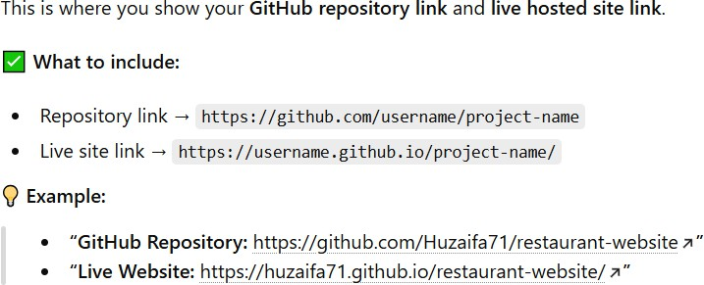

User Guide With Snapshots

Perform after mid so don’t do it in mid term

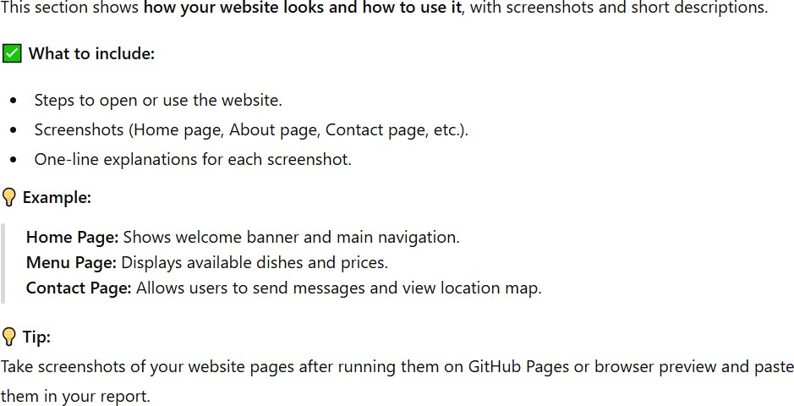
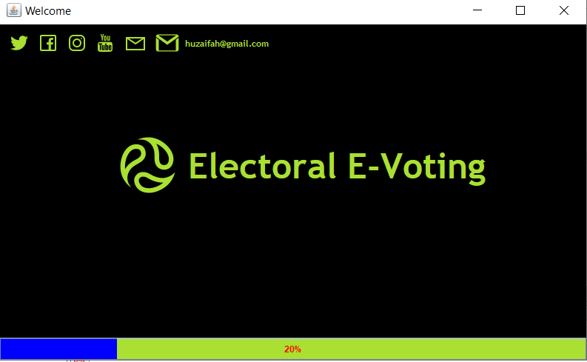

Department of Computer Science

Panel_View for Login and Registration (Admin Procedure Demonstration
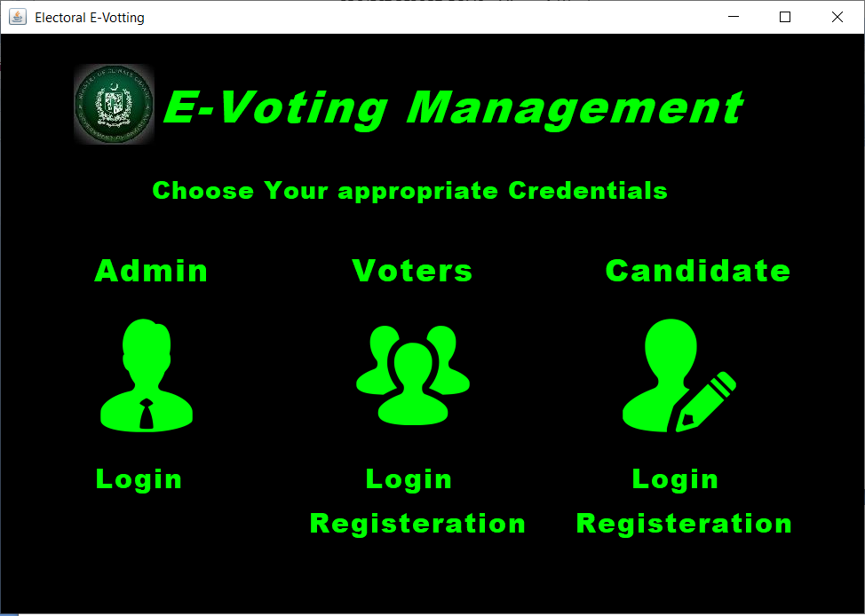

Flowchart/System flow diagram

Perform after mid so don’t do it in mid term

C
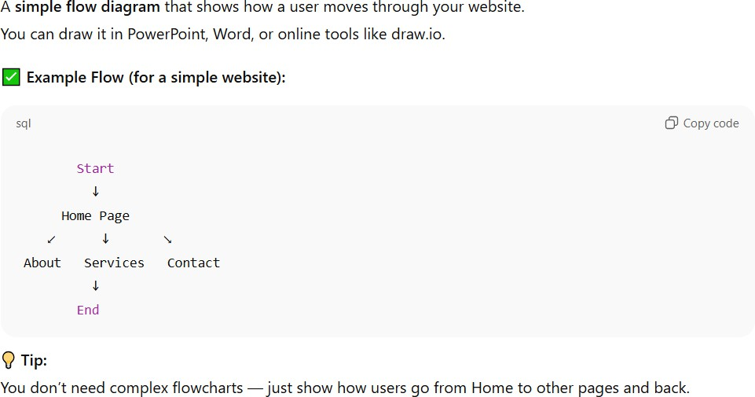

Department of Computer Science

Conclusion

B
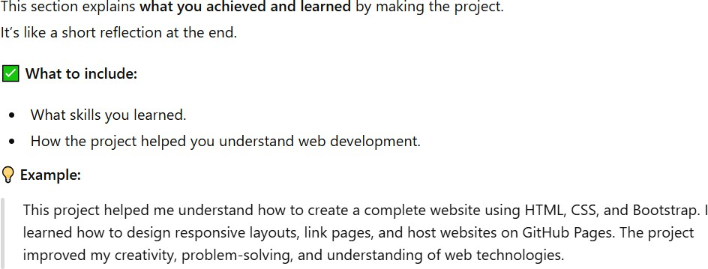

Future Expansion

B
